**Brandwiki : Requirements and suggestions**

**Requirement :**

Following are the tasks that has to recoded based on the redesigned sql attached here with! Please don't compromise anything in the below requirements,so will not be the performance[to an extend].

1. Please use `wp_bw_category`,`wp_bw_language` and `wp_bw_target_country` for storing the categories,languages, and locations for sites. Please use the same in  site creation forms too.
2. Please use `wp_bw_site_category`,`wp_bw_site_language` and `wp_bw_site_target_country` for storing the categories,languages, and locations for sites. Please avoid the usage of meta there.
3. Similiarly,please avoid the site meta and use `wp_bw_site_profile` table for storing and retrieving the other site details.

**Why avoid Meta(or serialized data):**

Use of serialized data is generally considered as a bad practice especially when you want your data to be searchable /readable. It makes the DB more difficult to read/query and difficult to maintain hence affects the performance.

Generally we use serialized data in cases like “must store but will hardly ever use” which is certainly not the case in our scenarios.

Ref: <http://stackoverflow.com/questions/12600956/is-it-good-practice-to-use-serialize-in-php-in-order-to-store-data-into-the-db>

<http://stackoverflow.com/questions/31724349/should-i-use-serialized-data-to-store-it-in-my-db-for-invoice>

<https://www.percona.com/blog/2010/01/21/when-should-you-store-serialized-objects-in-the-database/>

**Please use indexes:**

Please utilize the index feature of sql whenever you design a database. An **index** is used to speed up the performance of queries. It does this by reducing the number of database data pages that have to be visited/ scanned.

Ref: <http://stackoverflow.com/questions/2955459/what-is-an-index-in-sql>

In MySQL you can use EXPLAIN in front of your SELECT statement to see if your query will make use of any index. This is a good start for troubleshooting performance problems.

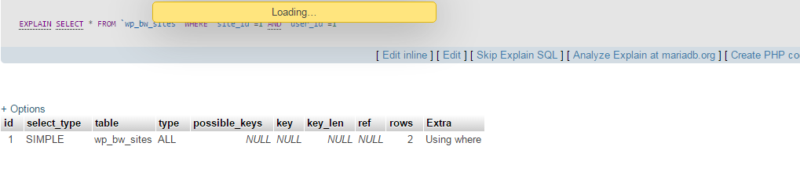

This happens because,indexed keys are not used in the where clause or proper indexing is not done. Instead it should be

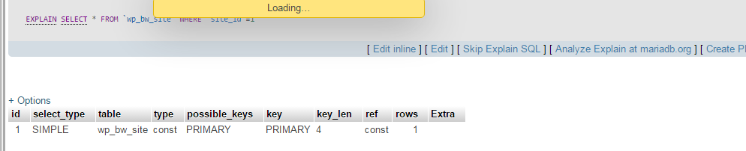

Read more here: <http://dev.mysql.com/doc/refman/5.0/en/explain.html>

Obviously, **Normalization** of DB should also be taken care of, when you design relational databases to avoid data redundancy and to increase the performance. But experts say, compromising in NFs can be done if it contributes in performance improvement.

Read at: http://www.studytonight.com/dbms/database-normalization.php

**NB: The current requirement takes care of only the serialized (Meta) data since it is very urgent to proceed.**